
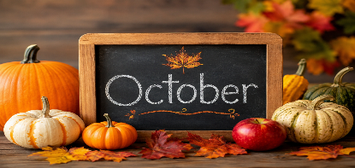
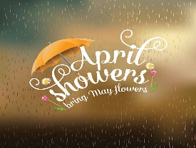
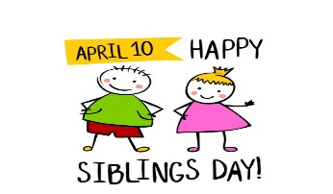
The Cathedral School Menu

~ October 2026 ~

Monday | Tuesday | Wednesday | Thursday | Friday
 | 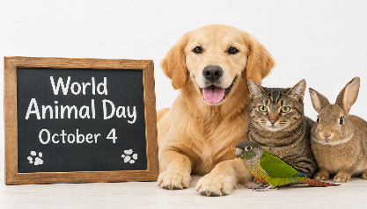 | 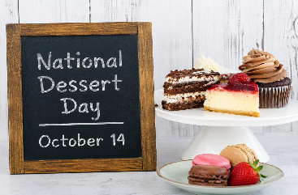 | 1  S – Nutri-Grain Bars  L – Chicken Nuggets, Baked  Beans, Apple Slices & Roll  S - Vanilla Wafers | 2  S – Cheez-Its  L – Turkey & Cheese  Sandwiches, Mandarin  Oranges, & Veggies  S - Pretzels
5  S – Goldfish  L – Chicken Tacos, Mexican  Corn & Pineapples  S - Vanilla Wafers | 6  S – Graham Crackers  L – BBQ Beef Slider, Baked  Beans, & Apples  S – Chocolate Chip Cookies | 7  S – Nutri-Grain Bars  L – Roast Turkey w/  Cheese Sub, Cooked  Carrots, & Pears  S - Cheese Balls | 8  S – Pop Tarts  L – Oven Fried Chicken  Green Beans &  Mandarin Oranges  S - Animal Crackers | 9  S – Special K Bars  L - Turkey Sandwiches,  Carrots, Fruit Cocktail  S – Shortbread Cookies
12  S – Cheerios  L – Rotisserie Chicken & Rice,  Corn & Pears  S - Pop Tarts | 13  S – Cheese Crackers  L - Cheese Burgers, Baked  Beans, & Melon  S – Pretzels | 14  S – Cheez-Its  L – Chicken & Rice,  Green Peas,  Tropical Fruit  S - Vanilla Wafers | 15  S – Chex Mix  L – Swedish Meatballs, Green  Beans, & Apple Slices  S - Animal Crackers | 16  S – Goldfish  L – Turkey & Cheese Sandwich,  Pineapples, & Mixed Veggies  S - Pretzels
19  S – Graham Crackers  L – Shredded BBQ Chicken  Sandwiches, Baked Beans,  & Peaches  S - Cheese Balls | 20  S – Nutri-Grain Bars  L – Meatloaf, Succotash,  Fruit Cocktail & Rolls  S – Chocolate Chip Cookies | 21  S – Cheerios  L – Spaghetti, Corn  Pears, & Garlic Bread  S - Pretzels | 22  S – Pop Tarts  L – Roasted Turkey w/ Gravy,  Green Beans, Bananas  & Corn Muffins  S - Shortbread Cookies | 23  S – Chex Mix  L- Turkey Sandwiches,  Cooked Carrots, Peaches  S – Vanilla Wafers
26  S – Special K Bars  L – Chicken Alfredo, Green  Beans, Pineapples  S - Cheerios | 27  S – Goldfish  L – Beef Nachos, Corn  & Mixed Fruit  S – Animal Crackers | 28  S – Graham Crackers  L – Hamburgers, Sweet  Potato & Seasonal  Fruit  S – Cheese Balls | 29  S – Nutri-Grain Bars  L – Chicken Nuggets, Baked  Beans, Apple Slices & Roll  S - Vanilla Wafers | 30  S – Cheez-Its  L – Turkey & Cheese  Sandwiches, Mandarin  Oranges, & Veggies  S - Pretzels
Milk is served with snacks and lunch. No fried or pork products are used.
All food is peanut free and has not been manufactured on any equipment that processes nut products.

