

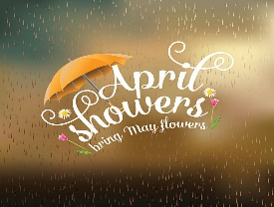
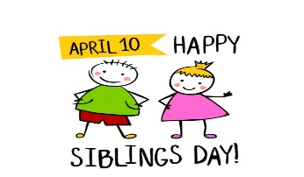
The Cathedral School Menu

~ July 2026 ~

Monday | Tuesday | Wednesday | Thursday | Friday
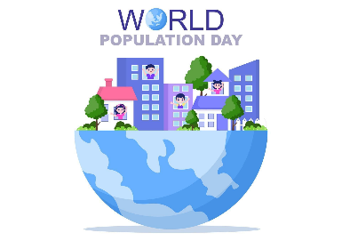 |  | 1  S – Cheez-Its  L – Chicken w/ Rice,  Green Peas,  Tropical Fruit  S- Vanilla Wafers | 2  S – Chex Mix  L – Swedish Meatballs, Green  Beans & Apple Slices  S- Animal Crackers | 3  No School  
6  S – Graham Crackers  L – Shredded BBQ Chicken  Sandwiches, Baked Beans,  & Peaches  S- Cheese Balls | 7  S – Nutri-Grain Bars  L – Meatloaf, Mashed Potato,  Fruit Cocktail & Rolls  S – Chocolate Chip Cookies | 8  S – Cheerios  L – Spaghetti, Green  Peas, Pears,  & Garlic Bread  S- Pretzels | 9  S – Pop Tarts  L – Roasted Turkey w/ Gravy,  Green Beans, Bananas  & Corn Muffins  S- Shortbread Cookies | 10  S – Chex Mix  L- Turkey Sandwiches,  Cooked Carrots, Peaches  S – Vanilla Wafers
13  S – Special K Bars  L – Chicken Alfredo, Green  Beans, Pineapples  S- Cheese Puffs | 14  S – Goldfish  L – Beef Nachos, Corn  & Mixed Fruit  S – Animal Crackers | 15  S – Graham Crackers  L – Hamburgers, Sweet  Potato Fries &  Seasonal Fruit  S – Cheese Balls | 16  S – Nutri-Grain Bars  L – Chicken Nuggets, Tater  Tots, Apple Slices & Roll  S - Vanilla Wafers | 17  S – Cheez-Its  L – Turkey & Cheese  Sandwiches, Mandarin  Oranges, & Veggies  S - Pretzels
20  S – Special K Bars  L – Hamburger Sliders, Baked  Beans, Pineapples, & Mac &  Cheese  S- Animal Crackers | 21  S – Pop Tarts  L – Philly Beef Sub, Ranch  Roasted Potatoes  & Peaches  S – Cheese Balls | 22  S – Cheerios  L – Turkey Sandwiches,  Yogurt & Pears  S – Shortbread Cookies | 23  S – Cheez-Its  L – Chicken Parmesan, Green  Beans, & Fruit Cocktail  S - Cheese Puffs | 24  S – Chex Mix  L- Turkey & Cheese  Sandwiches  Veggies, & Peaches  S – Pretzels
27  S – Goldfish  L – Chicken Tacos, Mexican  Corn & Pineapples  S - Vanilla Wafers | 28  S – Graham Crackers  L – BBQ Beef Slider, Baked  Beans, & Mandarin  Oranges  S – Chocolate Chip Cookies | 29  S – Nutri-Grain Bars  L – Roast Turkey w/  Cheese Sub, Cooked  Carrots, & Pears  S- Cheese Balls | 30  S – Pop Tarts  L – Oven Fried Chicken w/  Waffles, Green Beans &  Mandarin Oranges  S- Animal Crackers | 31  S – Special K Bars  L - Turkey Sandwiches,  Carrots, Fruit Cocktail  S – Shortbread Cookies
Milk is served with lunch. No fried or pork products are used.
All food is peanut free and has not been manufactured on any equipment that processes nut products.

