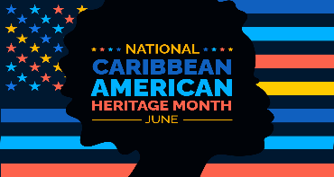
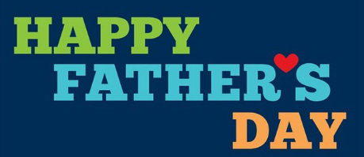
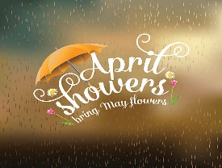
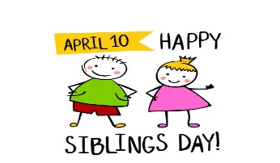
The Cathedral School Menu

~ June 2026 ~

Monday | Tuesday | Wednesday | Thursday | Friday
1  S – Graham Crackers  L – Shredded BBQ Chicken  Sandwiches, Baked Beans,  & Peaches  S- Cheese Balls | 2  S – Nutri-Grain Bars  L – Meatloaf, Mashed Potato,  Fruit Cocktail & Rolls  S – Chocolate Chip Cookies | 3  S – Cheerios  L – Spaghetti, Green  Peas, Pears,  & Garlic Bread  S- Pretzels | 4  S – Pop Tarts  L – Roasted Turkey w/ Gravy,  Green Beans, Bananas  & Corn Muffins  S- Shortbread Cookies | 5  S – Chex Mix  L- Turkey Sandwiches,  Cooked Carrots, Peaches  S – Vanilla Wafers
8  S – Special K Bars  L – Chicken Alfredo, Green  Beans, Pineapples  S- Cheese Puffs | 9  S – Goldfish  L – Beef Nachos, Corn  & Mixed Fruit  S – Animal Crackers | 10  S – Graham Crackers  L – Hamburgers, Sweet  Potato Fries &  Seasonal Fruit  S – Cheese Balls | 11  S – Nutri-Grain Bars  L – Chicken Nuggets, Tater  Tots, Apple Slices & Roll  S - Vanilla Wafers | 12  S – Cheez-Its  L – Turkey & Cheese  Sandwiches, Mandarin  Oranges, & Veggies  S - Pretzels
15  S – Special K Bars  L – Hamburger Sliders, Baked  Beans, Pineapples, & Mac &  Cheese  S- Animal Crackers | 16  S – Pop Tarts  L – Philly Beef Sub, Ranch  Roasted Potatoes  & Peaches  S – Cheese Balls | 17  S – Cheerios  L – Turkey Sandwiches,  Yogurt & Pears  S – Shortbread Cookies | 18  S – Cheez-Its  L – Chicken Parmesan, Green  Beans, & Fruit Cocktail  S – Cheese Puffs | 19  S – Chex Mix  L- Turkey & Cheese  Sandwiches  Veggies, & Peaches  S – Pretzels
22  S – Goldfish  L – Chicken Tacos, Mexican  Corn & Pineapples  S - Vanilla Wafers | 23  S – Graham Crackers  L – BBQ Beef Slider, Baked  Beans, & Mandarin  Oranges  S – Chocolate Chip Cookies | 24  S – Nutri-Grain Bars  L – Roast Turkey w/  Cheese Sub, Cooked  Carrots, & Pears  S- Cheese Balls | 25  S – Pop Tarts  L – Oven Fried Chicken w/  Waffles, Green Beans &  Mandarin Oranges  S- Animal Crackers | 26  S – Special K Bars  L - Turkey Sandwiches,  Carrots, Fruit Cocktail  S – Shortbread Cookies
29  S – Cheerios  L – Rotisserie Chicken,  Corn, Pears, & Rolls  S – Cheese Puffs | 30  S – Cheese Crackers  L- Cheese Burgers, Baked  Beans & Melon  S – Pretzels | 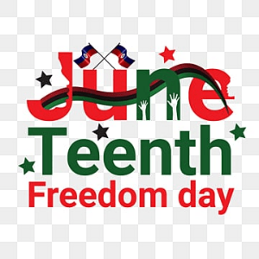 | 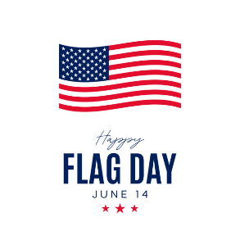 | 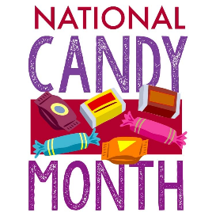
Milk is served with lunch. No fried or pork products are used.
All food is peanut free and has not been manufactured on any equipment that processes nut products.

