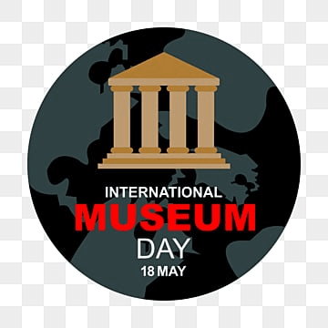
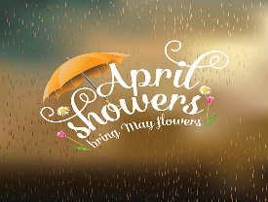
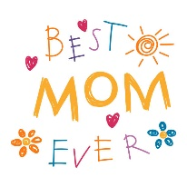
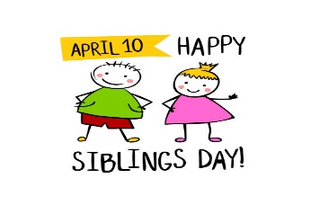
The Cathedral School Menu

~ May 2026 ~

Monday | Tuesday | Wednesday | Thursday | Friday
4  S – Special K Bars  L – Chicken Alfredo, Green  Beans, Pineapples  S- Oreos | 5  S – Goldfish  L – Beef Nachos, Corn  & Mixed Fruit  S – Animal Crackers | 6  S – Graham Crackers  L – Hamburgers, Sweet  Potato Fries &  Seasonal Fruit  S – Cheese Balls | 7  S – Nutri-Grain Bars  L – Chicken Nuggets, Tater  Tots, Apple Slices & Roll  S - Vanilla Wafers | 8  S – Cheez-Its  L – Turkey & Cheese  Sandwiches, Mandarin  Oranges, & Veggies  S - Pretzels
11  S – Special K Bars  L – Hamburger Sliders, Baked  Beans, Pineapples, & Mac &  Cheese  S- Animal Crackers | 12  S – Pop Tarts  L – Philly Beef Sub, Ranch  Roasted Potatoes  & Peaches  S – Cheese Balls | 13  S – Cheerios  L – Turkey Sandwiches,  Yogurt & Pears  S – Shortbread Cookies | 14  S – Cheez-Its  L – Chicken Parmesan, Green  Beans, & Fruit Cocktail  S - Oreos | 15  S – Chex Mix  L- Turkey & Cheese  Sandwiches  Veggies, & Peaches  S – Pretzels
18  S – Goldfish  L – Chicken Tacos, Mexican  Corn & Pineapples  S - Vanilla Wafers | 19  S – Graham Crackers  L – BBQ Beef Slider, Baked  Beans, & Mandarin  Oranges  S – Chocolate Chip Cookies | 20  S – Nutri-Grain Bars  L – Roast Turkey w/  Cheese Sub, Cooked  Carrots, & Pears  S- Cheese Balls | 21  S – Pop Tarts  L – Oven Fried Chicken w/  Waffles, Green Beans &  Mandarin Oranges  S- Animal Crackers | 22  S – Special K Bars  L - Turkey Sandwiches,  Carrots, Fruit Cocktail  S – Shortbread Cookies
25 No School   | 26  S – Cheese Crackers  L- Cheese Burgers, Baked  Beans, & Melon  S – Pretzels | 27  S – Cheez-Its  L – Chicken w/ Rice,  Green Peas,  Tropical Fruit  S- Vanilla Wafers | 28  S – Chex Mix  L – Swedish Meatballs, Green  Beans, & Apple Slices  S- Animal Crackers | 29  S – Goldfish  L – Turkey & Cheese Sandwich,  Pineapples, & Mixed Veggies  S - Pretzels
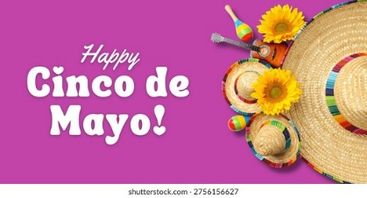 | 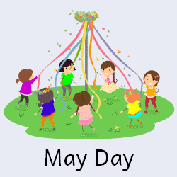 | 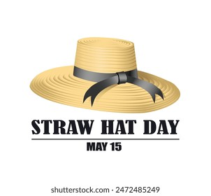 |  | 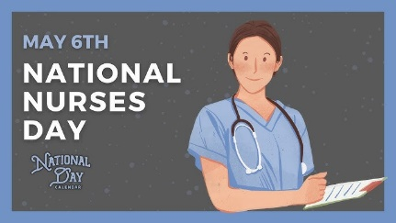
Milk is served with lunch. No fried or pork products are used.
All food is peanut free and has not been manufactured on any equipment that processes nut products.

