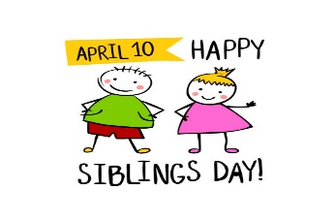

The Cathedral School Menu

~ April 2026 ~

Monday | Tuesday | Wednesday | Thursday | Friday
6  No School   | 7  S – Pop Tarts  L – Philly Beef Sub, Ranch  Roasted Potatoes  & Peaches  S – Cheese Balls | 8  S – Cheerios  L – Turkey Sandwiches,  Yogurt & Pears  S – Shortbread Cookies | 9  S – Cheez-Its  L – Chicken Parmesan, Green  Beans, & Fruit Cocktail  S - Oreos | 10  S – Chex Mix  L- Turkey & Cheese  Sandwiches  Veggies, & Peaches  S – Pretzels
13  S – Goldfish  L – Chicken Tacos, Mexican  Corn & Pineapples  S - Vanilla Wafers | 14  S – Graham Crackers  L – BBQ Beef Slider, Baked  Beans, & Mandarin  Oranges  S – Chocolate Chip Cookies | 15  S – Nutri-Grain Bars  L – Roast Turkey w/  Cheese Sub, Cooked  Carrots, & Pears  S- Cheese Balls | 16  S – Pop Tarts  L – Oven Fried Chicken w/  Waffles, Green Beans &  Mandarin Oranges  S- Animal Crackers | 17  S – Special K Bars  L - Turkey Sandwiches,  Carrots, Fruit Cocktail  S – Shortbread Cookies
20  S – Cheerios  L – Rotisserie Chicken,  Corn, Pears, & Rolls  S - Oreos | 21  S – Cheese Crackers  L- Cheese Burgers, Baked  Beans, & Melon  S – Pretzels | 22  S – Cheez-Its  L – Chicken w/ Rice,  Green Peas,  Tropical Fruit  S- Vanilla Wafers | 23  S – Chex Mix  L – Swedish Meatballs, Green  Beans, & Apple Slices  S- Animal Crackers | 24  S – Goldfish  L – Turkey & Cheese Sandwich,  Pineapples, & Mixed Veggies  S - Pretzels
27  S – Graham Crackers  L – Shredded BBQ Chicken  Sandwiches, Baked Beans,  & Peaches  S- Cheese Balls | 28  S – Nutri-Grain Bars  L – Meatloaf, Mashed Potato,  Fruit Cocktail & Rolls  S – Chocolate Chip Cookies | 29  S – Cheerios  L – Spaghetti, Green  Peas, Pears,  & Garlic Bread  S- Pretzels | 30  S – Pop Tarts  L – Roasted Turkey w/ Gravy,  Green Beans, Bananas  & Corn Muffins  S- Shortbread Cookies | 1  S – Chex Mix  L- Turkey Sandwiches,  Cooked Carrots, Peaches  S – Vanilla Wafers
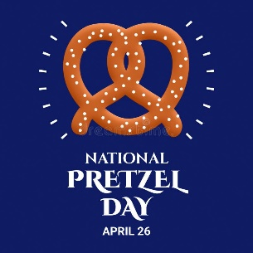 | 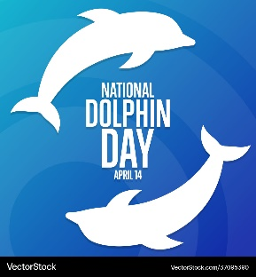 |  | 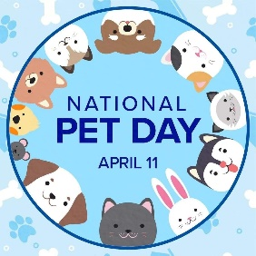 | 
Milk is served with lunch. No fried or pork products are used.
All food is peanut free and has not been manufactured on any equipment that processes nut products.

