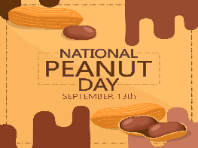
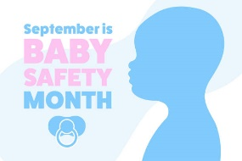
The Cathedral School Menu

~ September 2025 ~

Monday | Tuesday | Wednesday | Thursday | Friday
1  School Closed  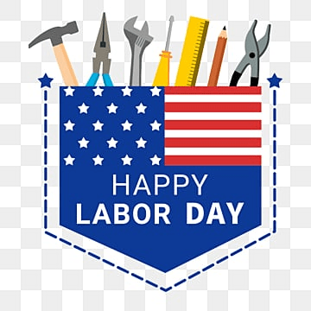 | 2  S – Cheese Crackers  L – Beef Nachos, Corn  & Mixed Fruit  S – Vanilla Wafers | 3  S – Blueberry Muffins  L – Hamburgers, Sweet  Potato Fries &  Seasonal Fruit  S – Apple Sauce | 4  S – Scooby Snacks  L – Chicken Nuggets, Tater  Tots, Apple Slices & Roll  S - Rice Krispie Treats | 5  S – Granola Bars  L – Turkey & Cheese  Sandwiches, Mandarin  Oranges, & Veggies  S - Pretzels
8  S – Goldfish  L – Hamburger Sliders, Baked  Beans, Pineapples, & Mac &  Cheese  S- Graham Crackers | 9  S – Cheese Crackers  L – Philly Beef Sub, Ranch  Roasted Potatoes  & Peaches  S – Fruit Cups | 10  S – Blueberry Muffins  L – Beef Bologna  Sandwiches, Yogurt  & Pears  S – Lorna Doones | 11  S – Scooby Snacks  L – Chicken Parmesan, Green  Beans, & Fruit Cocktail  S - Chex Mix | 12  S – Granola Bars  L- Turkey & Cheese  Sandwiches, Veggies,  & Peaches  S – Animal Crackers
15  S – Goldfish  L – Chicken Taco’s, Mexican  Corn & Pineapples  S - Sun Chips | 16  S – Cheese Crackers  L – BBQ Beef Slider, Mixed  Veggies, & Mandarin  Oranges  S – Vanilla Wafers | 17  S – Blueberry Muffins  L – Roast Turkey w/  Cheese Sub, Cooked  Carrots, & Pears  S- Apple Sauce | 18  S – Scooby Snacks  L – Oven Fried Chicken w/  Waffles, Green Beans &  Mandarin Oranges  S- Rice Krispie Treats | 19  S – Granola Bars  L - Beef Bologna Sandwiches,  Carrots, Fruit Cocktail  S – Pretzels
22  S – Goldfish  L – Rotisserie Chicken,  Corn, Pears, & Rolls  S - Graham Crackers | 23  S – Cheese Crackers  L- Cheese Burgers, Baked  Beans, & Melon  S – Fruit Cups | 24  S – Blueberry Muffins  L – Chicken w/ Rice,  Green Peas,  Tropical Fruit  S- Lorna Doones | 25  S – Scooby Snacks  L – Swedish Meatballs, Green  Beans, & Apple Slices  S- Chex Mix | 26  S – Granola Bars  L – Turkey & Cheese Sandwich,  Pineapples, & Mixed Veggies  S - Animal Crackers
29  S – Goldfish  L – Shredded BBQ Chicken  Sandwiches, Baked Beans,  & Peaches  S- Sun Chips | 30  S – Cheese Crackers  L – Meatloaf, Mashed Potato,  Fruit Cocktail & Rolls  S – Vanilla Wafers | 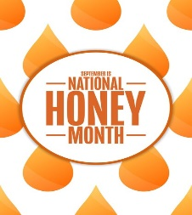 | 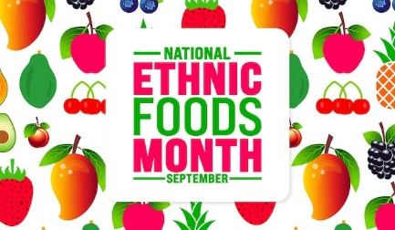 | 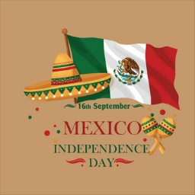
Milk is served with lunch. No fried or pork products are used.
All food is peanut free and has not been manufactured on any equipment that processes nut products.

